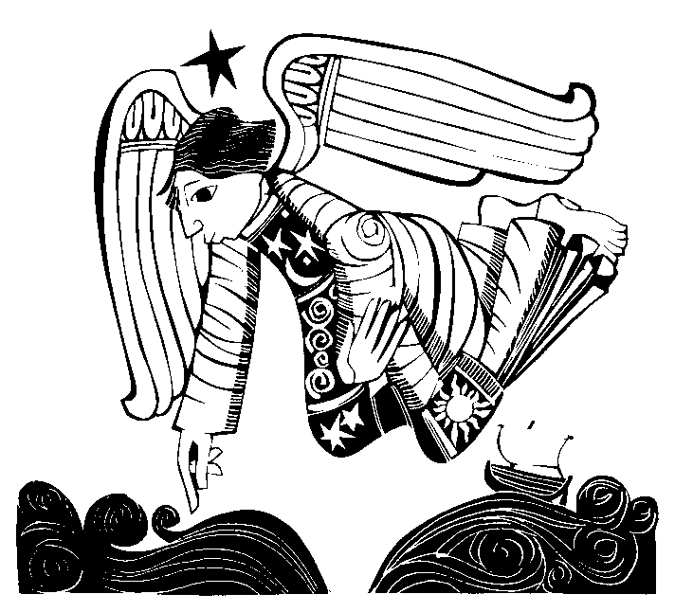

Christ Church Anglican

Church, Mt Gambier

**Palm Sunday of the**

**Lord’s Passion**

**Isaiah 50:4-7 - The Mystery of Suffering**

Welcome to the Anglican Church of Mt Gambier. The speaker of today's first reading is a victim. He speaks, but people beat him, pull out the hairs of his beard, slap and spit on him. Why? He suffers all this because he has spoken God's word. Every morning God speaks to him and enables him to speak to others. This word gets him into trouble.

But the speaker does not quit . Nor does he curse God who gives him these pointed words. He remains firm, committed to the word God gives him, even in the face of resistance.

Although Isaiah wrote about the difficulties faced by faithful Israel in the midst of enemies, Christians read through these lines and see the image of Jesus. He received God's word, spoke it with eloquence, and suffered at the hands of his enemies.

Do your words ever get you into trouble? Does it happen even when you say the right thing? If so, you stand in a long line of those who suffer because they are servants of God.

The victim on the cross hangs in full view in our churches. Christians can face the agony of suffering as it befell Jesus and as it comes to us, because we know there is something more.

*Written by Paul Turner. Copyright © 2009, Resource Publications, Inc., 888-273-7782, www.rpinet.com. All rights reserved. Reprinted with permission from Lectionary Bulletin Inserts, Year B: First and Second Readings.*

-----------------------------------------------------------------------

**BEFORE** the service, talk to God. **From today's Gospel**:

**During** the service, listen to God [Jesus prayed]

**After the service**, talk with each other. "Father, if you are willing, take this cup away

from me; still, not my will but yours be done."

PLEASE TAKE SPARE PEW SHEETS to anyone **Reflection:**

housebound or absent this morning Jesus endured intense emotional and

psychological pain. He experienced defeat,

discouragement, abandonment, disappointment

and frustration. Those suffering from similar interior

distress can find compassion and healing in their

companion Jesus. The one who prayed "Father, if you

are willing, take this cross away from me…," will

strengthen the faith of those who word the same

**FAITH BOOK** prayer out of the abyss of their inner turmoil.

Mini-reflections on the Sunday scripture

readings designed for persons on the run.

**So we ask ourselves:**

* When have I been distressed and experienced inner healings at the hands of Jesus?
* To whom can I be an instrument of healing in their in their emotional distress?

Jude Siciliano, OP

Dominican Southern Province, USA

**F**



*him come and die.* It may be a death

Holy Week begins with Jesus taking his like that of the first disciples who had

city not as a Roman governor would on a to leave home and work to follow him,

decked-out warhorse, but on a donkey, the or it may be a death like Luther's, who

beast of burden for all the poor. The crowd had to leave the monastery and go out

goes crazy, lining the streets with their clothes and palms into the world. But it is the same death

and shouting Hosanna, which means 'save us'. By the end every time - death in Jesus Christ, the

of the week things will be radically different. Jesus will death of the old man at his call.

die on the cross, virtually alone, nailed there by our *(The Cost of Discipleship, 99)*

sins. But one thing is certain: we will be saved.

* Pray for all who know the pain and desolation We have now entered into Holy Week,

of being abandoned by friends and family. May where we enter into the mystery of this

they all find solace and comfort. death on the cross. And on this side of

* Give thanks for the work and witness of the the cross we might be tempted to

CAPA, the Council of the Anglican Provinces of Africa. become lost in mourning. But because

Text: Robert McLean © Anglican Board of Mission, 2025 we know the far side of the cross, we

trust in hope in the God who pierces

**b** death by death. This hope is for

babies killed, sons lost, lives given,

**Jesus was crucified for us**, once and for all: he does not worship interrupted by suffering and

want us to be crucified with him, to die alongside him, virus, because in Christ, our worship

but to receive the gift of new life he offers to us. And yet he is perfected through *his* suffering,

calls out for our faith, for our love, for our discipleship, our lives are saved by his death, the

from the cross. He asks us to see that his refusal to save death of a Son – the firstborn – and the

himself was his supreme act for us and for our salvation. Death of a child, the child of a Virgin.

He invites us, with the centurion, to marvel, to wonder, to Amen.

give thanks and praise, and to recognize his utter Fr. Clint Wilson

faithfulness, his complete righteousness.

Jeremy Worthen

What Did Jesus Do?

**V**

Monastic Wisdom:

**E**

*Trust*

**Palm Sunday and Death's Defeat**

From the very beginning, the sacrifice of the cross has Belief and trust include doubt and

called forth sacrifice from those who would walk with Jesus, struggle. They do not blindly ignore the

even his mother - especially his mother. His followers have hard. Believing and trusting God

a sacrifice to give, not because they have earned it, but means an ongoing reliance and

because grace is not cheap - it was paid for in blood, and assured confidence in the midst of

continues to be paid for in blood by the martyrs, the struggle. Trust does not deny

slaughtered innocent. Few know this better than Dietrich struggle, but names the pain of

Bonhoeffer, whose feast (the date of his martyrdom) will fall struggle. with continued expectation.

this week on Maundy Thursday. He wrote: The cross is laid Br. Luke Ditewig, SSJE

on every Christian. The first Christ-suffering which every

man must experience is the call to abandon the attachments *Spice*

of this world. It is that dying of the old man which is the

result of his encounter with Christ. As we embark upon I know that I leave ignored or under-

discipleship we surrender ourselves to Christ in union with used much of what God has stocked

his death - we give over our lives to death. Thus it begins; my pantry with. And this is a shame,

the cross is not the terrible end to an otherwise god-fearing because God has stocked our pantries

and happy life, but it meets us at the beginning of our lavishly and lovingly. What spice have

communion with Christ. *When Christ calls a man, he bids* you been avoiding? What identity do

you ignore or hide, whether consciously or olive branches, which delight the eye

unconsciously? What would it mean to lay claim for a few hours and then wither, but

to it, to lean into it? What new invitations, what fresh ourselves, clothed in his grace, or

relationships, may result? rather, clothed completely in him.

Br. Lain Wilson, SSJE

We who have been baptized into Christ

*Ask*  must ourselves be the garments that

we spread before him. Let our souls

Our relationship with God calls forth a willingness to take the place of the welcoming

expose our hearts. This is as true in our relationships branches as we join today in the

with human companions as it is with God. Do we have children's holy song: "Blessed is he

the courage - the resilience - the trust - to name our who comes in the name of the Lord.

needs aloud? Ask, search, knock…and become the Blessed is the king of Israel."

child you are in God's eyes.

Br. Keith Nelson, SSJE St. Andrew of Crete 7th/8th C,

Sermon 9 for Palm Sunday

J.Robert Wright,

Readings for the Daily Office from the Early Church

**? J**

**Fourth Century Jerusalem** That beast on which Christ sits, is it

not you, who glorify and carry Christ

As the eleventh hour draws near, that particular passage in your own bodies, as the apostle

from Scripture is read in which the children bearing says?

palms and branches came forth to meet the Lord, saying: St. Bernard of Clairvaux,

"Blessed is the one who comes in the name of the Lord." Dominica Palmarum I.4

The bishop and all the people rise immediately, and then

everyone walks down from the top of the Mount of Olives,

with the people preceding the bishop and responding

continually with "Blessed is the one who comes in the name **}**

of the Lord" to the hymns and antiphons. All the children who

are present here, including those who are not yet able to walk Glory be to You, who laid your cross

because they are too young and therefore are carried on their as a bridge over death, that souls

parents' shoulders, all of them bear branches, some carrying might pass over it from the dwelling

palms, others, olive branches. And the bishop is led in the of the dead to the dwelling of life!

same manner as the Lord once was led. From the top of the St. Ephraem the Syrian

mountain as far as the city and from there through the entire

city as far as the Anastasis, everyone accompanies the

bishop the whole way on foot, and this includes

distinguished ladies and men of consequence, reciting the

response all the while. **J**

Egeria,

Diary of a Pilgrimage,

Ancient Christian Writers, Vol 38

**For the beginning of Holy Week**

>

Assist us mercifully with your help,

**Our Souls as Branches** O Lord God of our salvation,

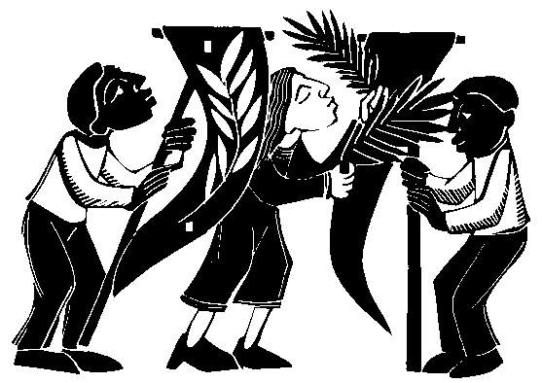 that we may enter with joy upon the

Let us run to accompany him as he hastens contemplation of those mighty acts,

toward his passion, and imitate those who whereby you have given us life and

met him then, not by covering his path with immortality;

garments, olive branches or palms, but by through Jesus Christ our Lord.

doing all we can to prostrate ourselves before him by being

humble and by trying to live as he would wish. Then we shall Amen.

be able to receive the Word at his coming, and God, whom

no limits can contain, will be within us.

… So let us spread before his feet, not garments or soulless

**Have you heard of 'Spy Wednesday'?**

As the days of Holy Week move forward, various events occur that directly lead to what will take place on Good Friday. Among these events was the fateful **betrayal of Jesus by one of his own disciples.**

Then one of the twelve, who was called Judas Iscariot, went to the chief priests and said,

"What will you give me if I deliver him to you?" And they paid him thirty pieces of silver. And from that moment he sought an opportunity to betray him.

*Matthew 26:14-16*

This action by Judas earned him the title of **"spy"** by medieval Christians, in accord with the traditional definition of the English word, **"one who keeps secret watch on a person or thing to obtain information."**

From Wednesday onward, Judas secretly watched for a chance to turn Jesus over to the chief priests, and so many Christians labelled this day as **"Spy Wednesday".**

In the same vein various cultures reflected the sombre mood of this day by calling it **"Black Wednesday"** or "Wednesday of Shadows," which also corresponds to the liturgical rite of Tenebrae that is celebrated on this day.

It is also called **"Silent Wednesday"**, as the Gospels do not record any activities in the life of Jesus. The only event is the secret meeting of Judas with the chief priests.

Wednesday's events usher in the final days of Jesus' life on earth and directly lead to the sacrifice of Jesus on Good Friday.

aleteia.org

**Three signs preceded the death of Jesus:**

darkness over the earth, the split in the Temple curtain, and Jesus's final prayer. All three point to the "end of time" motif. The darkness over the entire earth spoke of the mood that came with God's judgment. The tear in the Temple had many different interpretations: the Father's grief, the pouring of God's spirit from the Holy of Holies in the Temple upon the earth, and many others. The prayer was a sign of hope, entrusting his life to the Father. The darkness, the violence in the Temple, and the self-giving of the Christ prefigured the Final Judgment. The difference, of course, between these events and the final days lie in the particular, not the general. These events happened to Jesus. In the end, they will happen to all. All will suffer darkness and violence. The suffering will give people the same and only choice Jesus had in his dying breath: to trust God or not.

As a witness to the events, the centurion declared Jesus "right" with God and the world. He was the last of three who testified to Jesus' innocence and righteousness. (The first two were Pilate and the "good thief". ) All three were Gentiles or outcasts, the audience that would soon fill the Christian communities throughout the Roman Empire.

*Larry Broding*

*word-sunday.com*