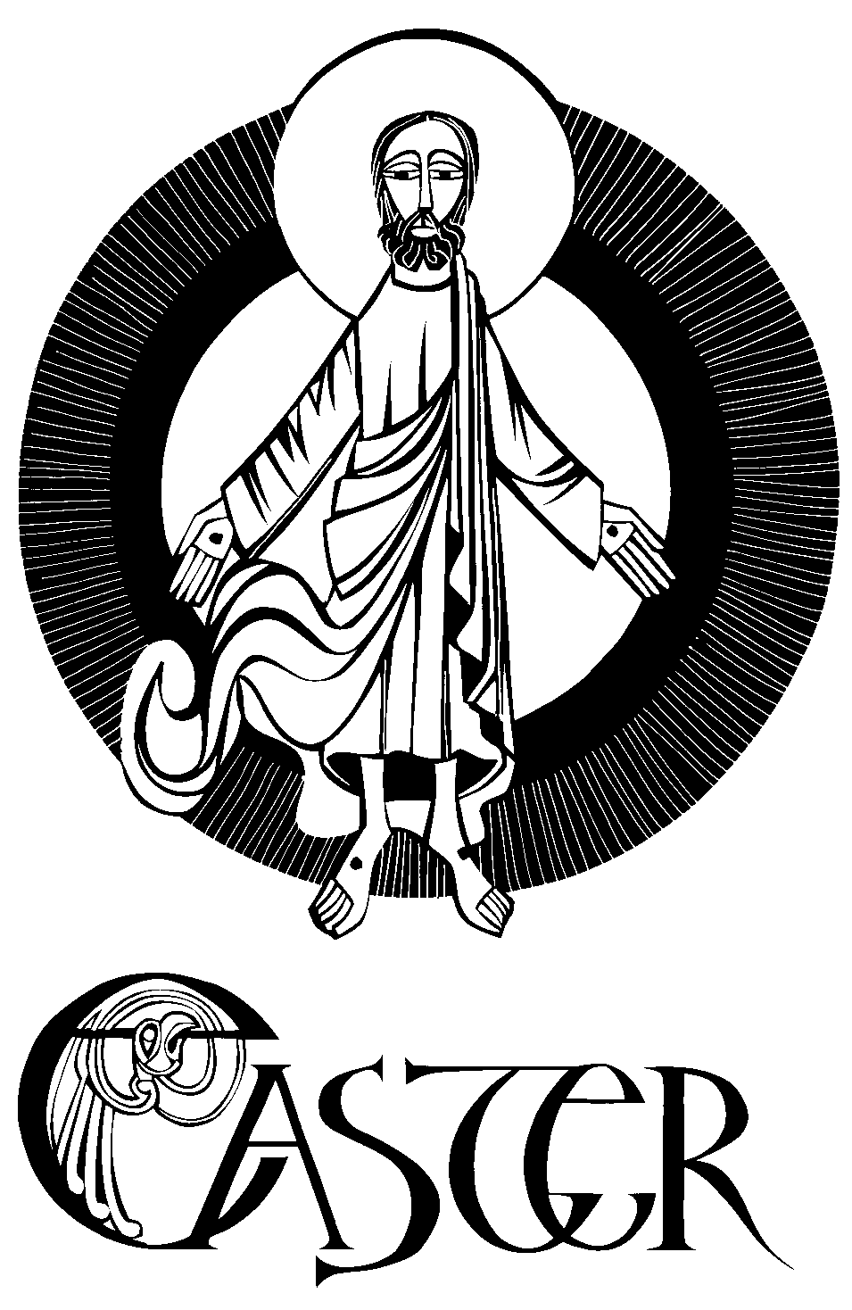

Christ Church Mt Gambier

St Luke’s, Mt Schank

Anglican Churches

**Easter Sunday**

*Acts 10:34a, 37-43 -* **All Is New**

W

**elcome to the Anglican Churches of Mount Gambier.** “What’s new?” That is what we ask when we want to hear a story. Stories celebrate the great moments of life. When you hear one, it fills you with delight. When you tell one, you fulfill an inner desire to share what has shaped your life anew.

After Jesus rose from the dead, the disciples did not wait for people to ask, “What’s new?” They proudly proclaimed it: “God raised Jesus on the third day and granted that he be visible to us witnesses”. Now, that is new!

If you have kept a good Lent, you know very well what is new with you. You are what is new! You have faced your sin, admitted your fault, and accepted your dependence upon God’s help. You have prayed and fasted with the community. You have loved your neighbour. Because you have emptied a place inside yourself, you created a space for God’s Spirit to enter. Christ is risen indeed, and he has appeared to you! You are now a witness of all that God can do.

This Easter Day, tell your story. Tell your faith. Let joy radiate from your face and loosen your tongue! Jesus lives!

Written by Paul Turner. Copyright © 2009, Resource Publications, Inc., 888-273-7782, www.rpinet.com. All rights reserved. Reprinted with permission from *Lectionary Bulletin Inserts, Year B: First and Second Readings.*

**-----------------------------------------------------------------------**

**Before** the service, talk to God.

During the service, listen to God.

After the service, talk with each other.

**~~~~~~~~**

**Please Take Spare Pew Bulletins** to anyone housebound or absent this morning.

**~~~~~~~~**

**FAITH BOOK**

Mini-reflections on the Sunday scripture readings designed for persons on the run.

**From today’s Gospel:**“Then the other disciple [the one whom Jesus loved] also went in, the one who had arrived at the tomb first, and he saw and believed.”

**Reflection:**

With the “beloved disciple” we have been loved with a love that death cannot overcome. We have come to believe in the permanence of that love and trust that neither sin nor even death, will separate us from it. We believe we are being held fast by that love–we have eternal life now, into death and beyond death.

**So we ask ourselves:**

* Have I had any recent concrete experience of Christ’s love for me?
* How has that affected my outlook in times of loss and disappointment?

*Jude Siciliano, OP*

*Dominican Southern Province, USA*

**F**

Jesus’ ministry among women is shown at its fullest today because the first people to know about the Resurrection were Mary Magdalene and the other Mary. Not Peter, not even John, but the women – Mary Magdalene, Joanna, Mary the mother of James, and the other women with them, according to Luke. It was they who first preached the Gospel of Jesus’ rising from death to the world.

* Give thanks for the ministry of women in the church – lay people, religious, deacons, bishops and priests.
* Give thanks for work and witness of the Nippon Sei Ko Kai, The Anglican Church of Japan.

*Text:* Robert McLean © Anglican Board of Mission, 2025

**v**

**The Empty Tomb**

*Have you ever seen something so unusual that the experience gave you pause? Did you jump to a conclusion? What happened?*

While I have lived in California for the past 40 years, I was born in Missouri, the "Show Me" state. I tend to have a sceptical streak. If I see something unbelievable, I don't believe it.

Yet, there are events and experiences that have stopped me in my tracks. And have challenged my scepticism. Many times these events and experiences have deepened my faith life. The only explanation I can give them is "God."

One woman had such an experience. She told two others who saw what she saw. Only one of these witnesses saw God's hand in the experience. The empty tomb proved a transcendent event.

This resurrection scene from John's gospel emphasized the empty tomb as a cause for faith, not the appearance of Jesus. Later, the vision of the risen Lord would cause others to believe (Mary Magdalene in John 20:14-18 and Thomas 20:26-28).

*Larry Broding*

*word-sunday.com*

**Z**

“Jesus bestowed on his disciples and continued to give when he appeared to each and all. ‘Peace I give to you, my own peace’. On likely more than one occasion, the disciples were in hiding, fearing for their lives. Jesus came among them and simply breathed on them, and into them came his peace. We think of nothing but peace when we contemplate the face of St. Stephen at the time of his martyrdom. Saints Peter and Paul must have been the same way when they were slain in Rome: at peace.”

*Chip Prehn,*

***Peace Beyond Understanding***

**s**

**REFLECTIONS ON THEME**  
This Easter the focus is, of course, on the resurrection, but the particular emphasis is on the liberation that Jesus brings. It is notable that the Acts reading is included, reminding us of that great moment of inclusion in the church’s history, where Peter proclaims, “But God has shown me that I should no longer call anyone impure or unclean”. In addition, both Gospel readings focus on the women’s role in the great resurrection drama, especially Mary Magdalene – another great moment of inclusion in the history of God’s people. The message is clear – the resurrection is not just about finding life for after we die. It is a doorway to life now for all who are denied life through exclusion, oppression or judgment. The challenge, then, is to embrace this life each day – to learn to become both those who are enlivened by God’s resurrection life, in the face of the violence, oppression, injustice and death of our world, and to become those who bring resurrection to those around us, through service, welcome, generosity, compassion, solidarity, dignity and love. As long as the resurrection is only an anomaly in history, it has no real value for us. But, when it becomes a reality that infiltrates our lives and our beings, it transforms us into those whose every thought, word, action, value and attitude celebrates and releases life into our world.

*Sacredise*

**“Break Open the Tomb”**

Lord of Easter's Promise,  
I live in faith of the Resurrection,  
but such is the nature of my faith  
that so much of me remains entombed.

Break open the tomb.  
Where I've buried my compassion,

Break open the tomb.  
Where I've buried my sense of mercy,

Break open the tomb.  
Where I've buried my humility,

Break open the tomb.  
Where I've buried my humanity,

Break open the tomb.  
Where I've buried my love for my Heavenly Father,

Break open the tomb.  
Where I've buried my sense of joy,

Break open the tomb.  
Where I've buried my willingness to forgive,

Break open the tomb.  
Lord, in you I've found a Saviour no grave can withstand.  
Help me to roll away this stone  
And find the miracle of new life  
That I may live more fully in your saving grace.

Amen.

*Catholic Relief Services*

**d**

**Monastic Wisdom:**

**Passion**

Giving our life in love is not without suffering. Passion – Jesus’ passion and our passion – is both about love and suffering. The great mystery of life is how love and suffering coexist, and how they inform each other. Jesus shows us the way.

*Br. Curtis Almquist, SSJE*

**Crucible**

When we approach our spiritual life with the care and attention it deserves, we will arrive at thresholds we cannot cross without our inner lives seeming to get worse rather than better: more painful, more exposed, less manageable in all the old ways we know. God is love, but love is powerful. Love is a crucible that dismantles the self we have cherished.

*Br. Keith Nelson, SSJE*

**Interconnection**

Giving our life in love is not without suffering. Passion – Jesus’ passion and our passion – is both about love and suffering. The great mystery of life is how love and suffering coexist, and how they inform each other. Jesus shows us the way.

*Br. Jack Crowley, SSJE*

**c**

**EASTER ALLELUIA**

St. Augustine says: "We are Easter people; Alleluia is our song." Alleluia is one of those words that needs to be sung. We'll sing it over and over again this Easter season. What exactly does it mean? Literally, the word is a short form for the sentence: "God's people praise God!" But it's one of those words that defies translation, like "Hooray!" Even the instructions in our liturgical books say that if the Alleluia cannot be sung, it should be omitted. So whether liturgy is celebrated in a cathedral or a catacomb, "Alleluia" is our song.

*Copyright © 2009 Resource Publications, Inc.*

*All rights reserved*.**EASTER CANDLE**

During the Easter Season the Paschal Candle should be placed near where the Word of God is proclaimed. It is lit each time the people of God gather during the Easter Season. The Easter Candle has always had a connection with the Easter Vigil. It is during the Vigil that the candle was solemnly lit from the Easter fire. In former times the Paschal Candle was extinguished with great solemnity after the Gospel on the feast of Ascension Thursday. That ritual was a way of dramatizing the fact that the lighted candle represented the presence of the Risen Lord now ascended to the Father. Today, it is extinguished at Pentecost. In fact, the Paschal Candle is used throughout the year. It has a special significance at Baptisms and Funerals because the focus of both these events is on the new life that we share in the Risen Christ. Many churches burn it at all the Masses during the month of November as we remember those who have died. The Paschal Candle should be a reminder of the promise of Jesus: "Where two or three are gathered in my name, there I am in the midst of them."

*Copyright © 2009 Resource Publications, Inc.*

*All rights reserved.*

**V**

Up from the grave he arose,

With a mighty triumph o’er his foes;

He arose a victor from the dark domain,

And he lives for ever with his saints to reign,

He arose! He arose!

Alleluia! Christ arose!

*Robert Lowry*

h

**The seed quickens in countless hearts**  
Christ was in the tomb; the whole world was sown with the seed of Christ’s life; that which happened thirty years ago in the womb of the Virgin Mother was happening now, but now it was happening yet more secretly, yet more mysteriously, in the womb of the whole world.  Christ had already told those who flocked to hear Him preach that the seed must fall into the earth, or else remain by itself alone.  Now the seed of His life was hidden in darkness in order that His life should quicken in countless hearts, over and over again for all time.  His burial, which seemed to be the end, was the beginning.  It was the beginning of Christ-life in multitudes of souls.  It was the beginning, too, of the renewal of Christ’s life in countless souls.

*Caryll Houselander*

**6 $**

Over the chaos of the empty waters  
hovered the Spirit, bringing forth creation; God will repair what has been shattered,

so from the empty tomb the Second Adam but not by mending it with something

     issued triumphant. else. Rather, out of the old and very same

material of its origin, God will impart to it

an appearance of beauty pleasing to

Himself.

By the same Spirit we, regenerated *St. Hilary of Poitiers, 4thC*

into the body of our risen Saviour,

seek through the power of the new creation

     life everlasting **?**

By the same Spirit we are called to worship **Blessing of Homes at Easter**

God our Creator, Saviour, Sanctifier, It is an ancient custom for the parish priest

of whom the glory in both earth and heaven, to bless the homes of the faithful at Easter

     is manifested. using the hallowed Easter water. As this

***Monastic Breviary*** *(stanzas 1-2)* was traditionally done at every home in the

parish, it is a simple blessing, not the full

blessing of a new home. It may take place

**I** at any time during the Great Fifty Days of

Easter, and it is an excellent opportunity for

**Where he dwells** parishioners, family and friends to come

together in one another’s homes to

And yet you may not cling to this delight of his celebrate and come to the feast.

presence, for you are not only in the garden but

still in the desert as well, and he is the manna that *Full Homily Divinity*

you must seek each day, your daily bread. You have

no need to cling to this experience. Rather, you

must find him where he dwells in his brothers and

sisters. Go and tell the others the good news:

through the waters they are reborn into this garden

of the beginning, where his Father is their father,

and they are his brother and sister and mother.

Let them look deeply enough into the waters of their

grief and they will experience this for themselves:

they will find the garden there and he, risen, in its midst.

*Bruno Barnhart*

***The Good Wine: Reading John from the Center***

