Easter Services – Some feedback please!
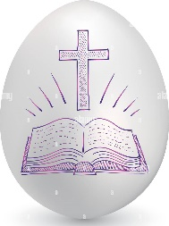
Our Easter Services were well-attended this year. We put effort into making them varied and well-constructed, integrating Anglican tradition and a contemporary atmosphere. We hope they have been well-received and were welcoming and approachable for new-comers. In the spirit of continuous improvement, please give the Liturgy Team some feedback.
- Are you responding as (please )

an individual a couple a family
- Which service/s did you attend?

Palm Maundy Good Vigil Easter Day
Sunday Thursday Friday (Mt Schank)

- Please describe what you enjoyed.

- Please describe what we could do better next year so that you, your family, or friends could get more from worship.

- Extra Space? PTO!
- Please place this in the collection plate, suggestion box, back door letter box, or give it to a member of Parish Council. An online version has been emailed with the pew sheet.
Easter Services – Some feedback please!
Our Easter Services were well-attended this year. We put effort into making them varied and well-constructed, integrating Anglican tradition and a contemporary atmosphere. We hope they have been well-received and were welcoming and approachable for new-comers. In the spirit of continuous improvement, please give the Liturgy Team some feedback.
- Are you responding as (please )

an individual a couple a family
- Which service/s did you attend?

Palm Maundy Good Vigil Easter Day
Sunday Thursday Friday (Mt Schank)

- Please describe what you enjoyed.

- Please describe what we could do better next year so that you, your family, or friends could get more from worship.

- Extra Space? PTO!
- Please place this in the collection plate, suggestion box, back door letter box, or give it to a member of Parish Council. An online version has been emailed with the pew sheet.

