Services in the Parish and Forthcoming Events

MONTH | DAY | DATE | TIME | ACTIVITY | ORGANISED BY
March | Fri | 3rd | 6.00pm | World Day of Prayer @ Christ Church
 | Sun | 5th | 9.30am | Communion | Choir
 | Mon | 6th | 9.30am | Strategic Planning meeting in Ashworth Room
 | Tues | 7th | 3.15pm | Fundraising Team meeting in Ashworth Room
 | Thurs | 9th | 9.30am | Men Do Coffee @ Limestone Coast Pantry
 | Sun | 12th | 9.30am | Pathways | CMG
 | Fri | 17th | 9.30am – 4.00pm | Workshop for existing and future leaders of the parishes | Craig  Bailey
 | Sat | 18th | 9.30am – 2.30pm | Retreat for the lay faithful
 |  | 18th | 3.00pm | Interfaith prayer for Peace | CMG
 | Sun | 19th | 9.30am | Communion | Choir
 |  | 19th |  | Annual Meeting
 | Sat | 25th |  | Mini Market
 | Sun | 26th | 9.30am | Pathways – Baptism | CMG
 | Mon | 27th | 10.30am | Refreshments – Lady Day
 |  | 27th | 11.00am | LADY DAY Eucharist @ Christ Church, Strathalbyn | See notice in Vestry
June – July |  | 26th June – 17th July |  | Tour to Sri Lanka and Pilgrimage to the Holy Land
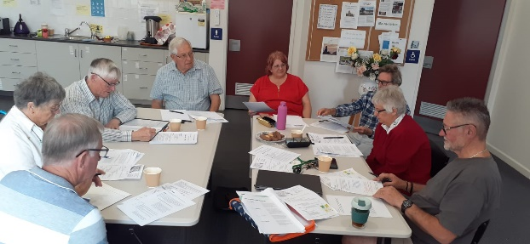
Participants at Strategic Planning meeting held last week

Services in the Parish and Forthcoming Events

MONTH | DAY | DATE | TIME | ACTIVITY | ORGANISED BY
March | Fri | 3rd | 6.00pm | World Day of Prayer @ Christ Church
 | Sun | 5th | 9.30am | Communion | Choir
 | Mon | 6th | 9.30am | Strategic Planning meeting in Ashworth Room
 | Tues | 7th | 3.15pm | Fundraising Team meeting in Ashworth Room
 | Thurs | 9th | 9.30am | Men Do Coffee @ Limestone Coast Pantry
 | Sun | 12th | 9.30am | Pathways | CMG
 | Fri | 17th | 9.30am – 4.00pm | Workshop for existing and future leaders of the parishes | Craig  Bailey
 | Sat | 18th | 9.30am – 2.30pm | Retreat for the lay faithful
 |  | 18th | 3.00pm | Interfaith prayer for Peace | CMG
 | Sun | 19th | 9.30am | Communion | Choir
 |  | 19th |  | Annual Meeting
 | Sat | 25th |  | Mini Market
 | Sun | 26th | 9.30am | Pathways – Baptism | CMG
 | Mon | 27th | 10.30am | Refreshments – Lady Day
 |  | 27th | 11.00am | LADY DAY Eucharist @ Christ Church, Strathalbyn | See notice in Vestry
June – July |  | 26th June – 17th July |  | Tour to Sri Lanka and Pilgrimage to the Holy Land
Participants at Strategic Planning meeting held last week

