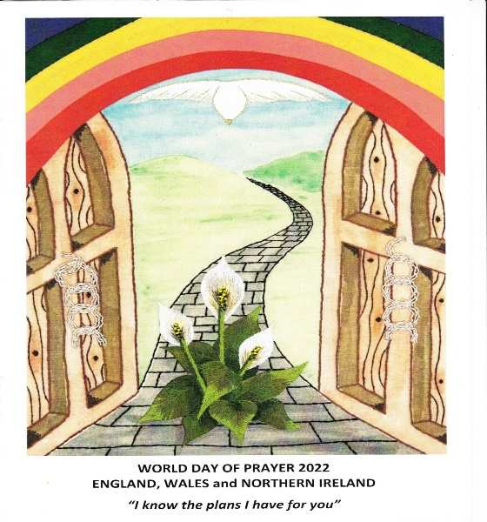


WORLD DAY OF PRAYER 2022
You are invited to join us

FRIDAY, 4th March
at
7.00pm

UNITING CHURCH
Elizabeth Street

Speaker : Rev’d Janice McWhinney
(currently living in Wagga Wagga NSW)

WORLD DAY OF PRAYER 2022
You are invited to join us

FRIDAY, 4th March
at
7.00pm

UNITING CHURCH
Elizabeth Street

Speaker : Rev’d Janice McWhinney
(currently living in Wagga Wagga NSW)

