GARAGE SALE & MINI-MARKET

Our final GS & MM for 2021 will be held on SATURDAY, 13TH NOVEMBER from 8.30am - 12.30pm. We are hoping to make this one even more successful than our previous ones this year.

Listed below are the stalls and convenors for each. Donations and offers of help on any of these stalls would be very much appreciated, especially the CAKES.

SHED: Trevor Christopher 0400 745 056
PLANTS: Andrew Hogg 0428 104 160 / Jeff Bowman 0487 486 260
PRODUCE & POT LUCK: Julienne Feast 8726 8019
CAKES: Roma Driscoll 0455 544 143
PRINTS & PICTURES: Bill Hudd 0477 504 223
CRAFT: Kathy MacIntosh 0447 255 790
SAUSAGE SIZZLE & PETROL RAFFLE: Graham Savage 0417800175

A mobile coffee van will be available until 10.30am.

Setting up: 7.00am Saturday morning.

We will be drawing the prizes for the Petrol Raffle at 12 noon.
****Please try to have raffle books RETURNED to the office by THURSDAY, 11TH NOVEMBER.

Any enquiries please contact the appropriate convenor or Jeff Bowman 0487 486 260.
BYO chairs

Parishioners are asked to please bring their fold-up chairs to the Memorial Garden Remembrance service on Sunday, 14th November.

This will help negate the need to carry chairs from the hall for the events, and subsequently having to pack them up again. Thank you

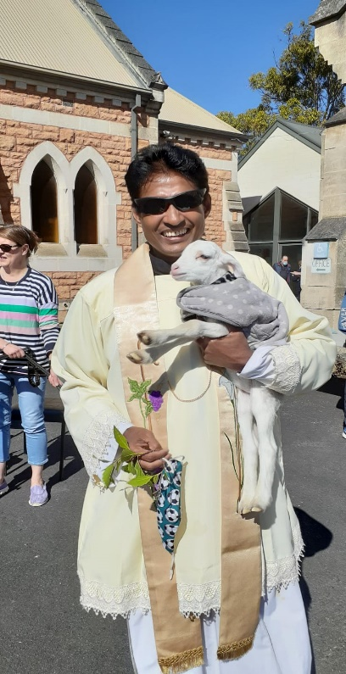
Images from the very successful Pet Service on Sunday, 31st October 2021
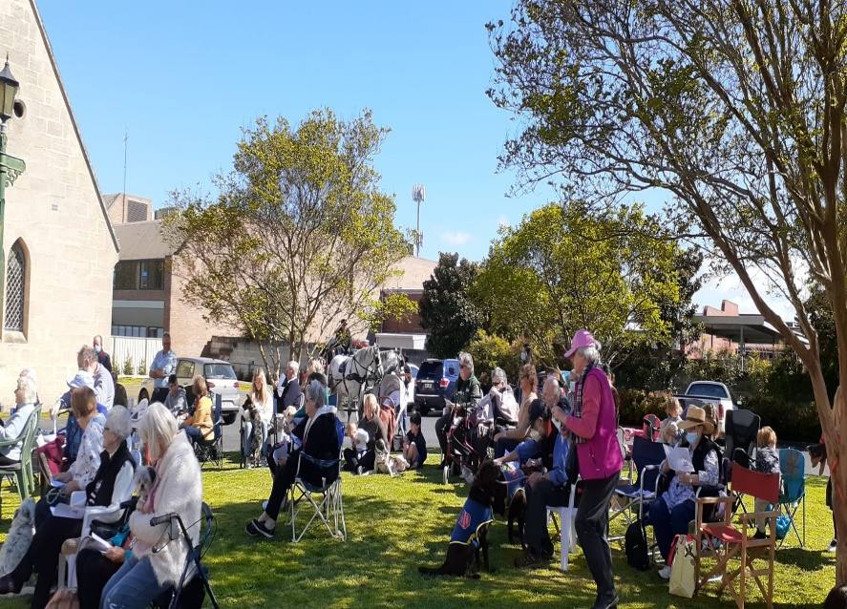

Have you given any thought to how you might be able to help with the clerical tasks in the Parish Office????

If there is anyone who feels that this is something they would like to spend some time at, please have a word with Lynn Fisher or Faye Hill for more information or just get in touch with someone on Parish Council and tell us some details of your time available and areas of interest.

